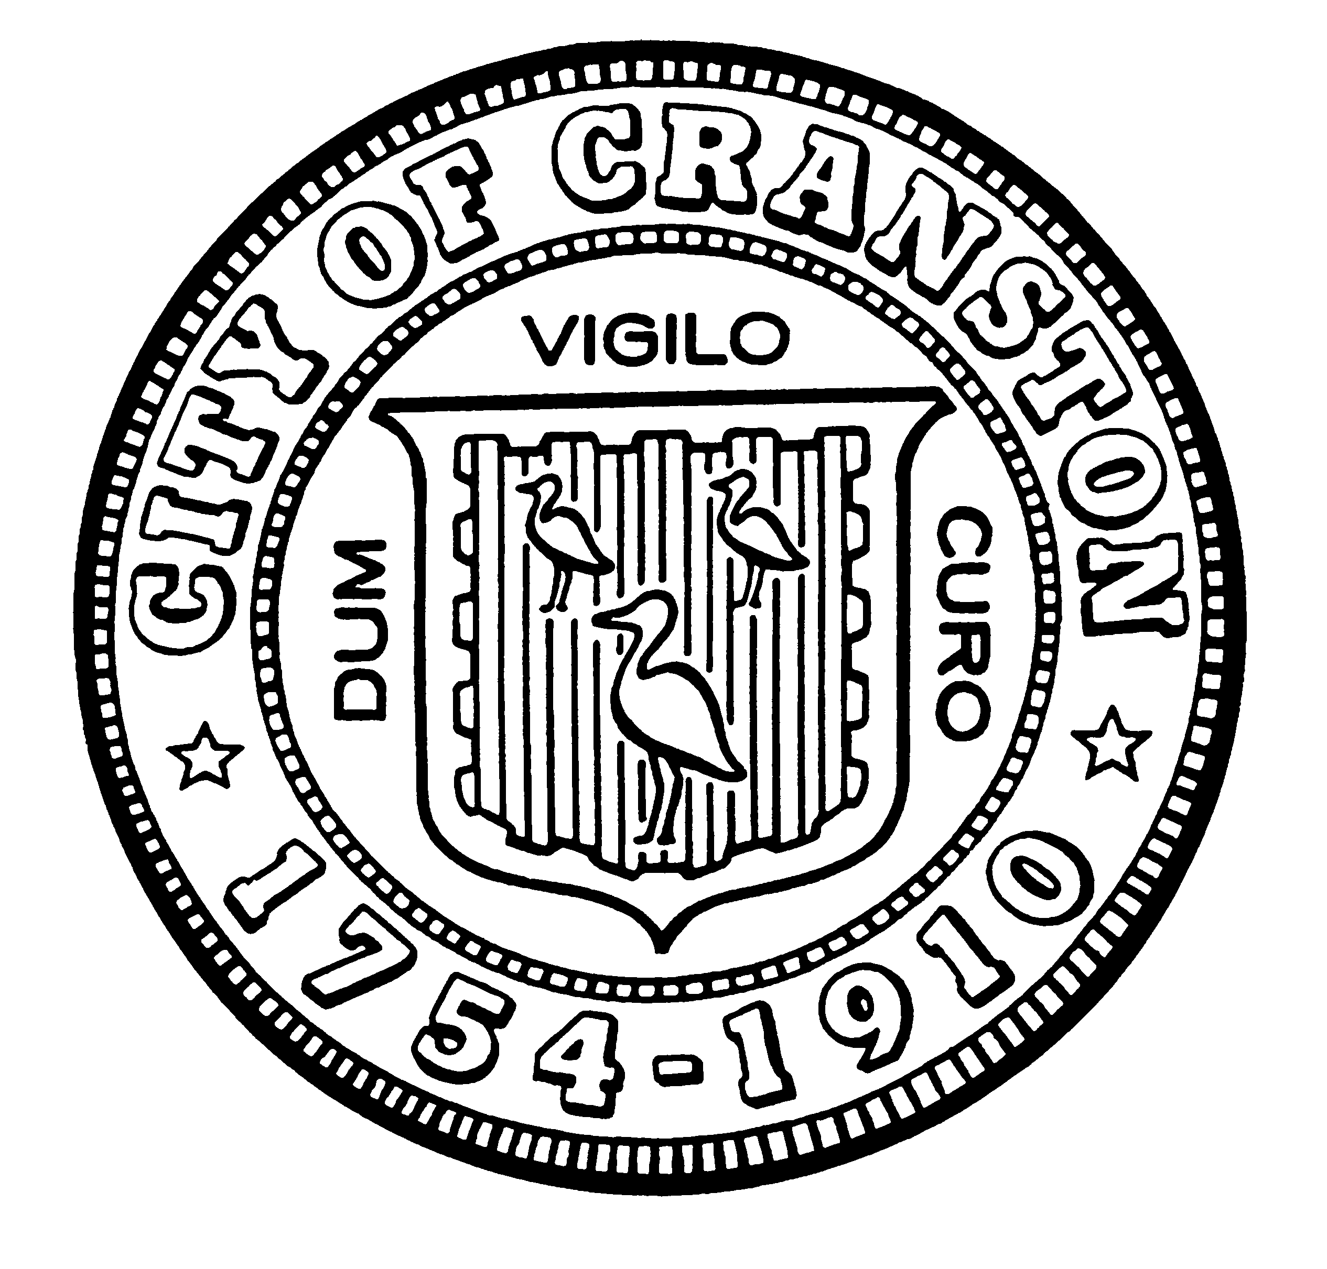

AFFORDABLE HOUSING COMMISSION
Derik Tutt Jason M. Pezzullo, Planning Director
Jeffrey P. Barone Tim G. Sanzi, Community Development
Annette Mann Bourne Kayland Arrington, OneCranston Health Equity Zone
Amy Rainone Lee A. Beliveau, CCAP
Frank DiZoglio

WEDNESDAY MAY 5, 2021 @ 5:30 P.M.

Virtual Zoom Meeting
City Of Cranston is inviting you to a scheduled Zoom meeting.

Topic: Monthly Meeting
Time: May 5, 2021 5:30 PM Eastern Time (US and Canada)

Join Zoom Meeting
https://us02web.zoom.us/j/85836691181?pwd=UzAyR3RRdi9tSC83dFZ1dEZ5djlBZz09

Meeting ID: 858 3669 1181

Passcode: 224775

One tap mobile
+13126266799,,85836691181#,,,,*224775# US (Chicago)
+16465588656,,85836691181#,,,,*224775# US (New York)

Dial by your location
+1 312 626 6799 US (Chicago)
+1 646 558 8656 US (New York)
+1 301 715 8592 US (Washington DC)
+1 346 248 7799 US (Houston)
+1 669 900 9128 US (San Jose)
+1 253 215 8782 US (Tacoma)
888 788 0099 US Toll-free
833 548 0276 US Toll-free
833 548 0282 US Toll-free
877 853 5247 US Toll-free

Meeting ID: 858 3669 1181

Passcode: 224775

Find your local number: https://us02web.zoom.us/u/kbEnTYRtOr

MONTHLY MEETING- MAY
AGENDA
- Approval of minutes of March 30, 2021 meeting
- Review of Commission’s purpose and duties
- Discussion on possible working groups

“Individuals requesting interpreter services for the hearing-impaired must notify the Office of the City Clerk at 461-1000 Ext. 3197 seventy-two (72) hours in advance of the hearing date.”

